Chapter 4 Pictures

Before I wrote all this out, I really didn’t know I felt this way deep down.
I can tell both Mami and Papi are really glad that Mr. Kennedy is going to be the American president.
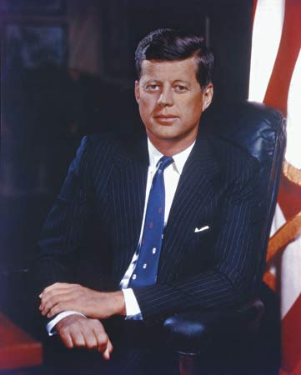

We are being overheard; be quiet.

Just thinking about losing Sammy, I start to cry.

Even though I’m almost in love with Sam Washburn, I can’t resist feeling proud when a Dominican corrects an American’s English.

“You have to be very careful,” she whispers, making the familiar gesture of cutting off her head. “Things will be happening soon for which there is no protection.”
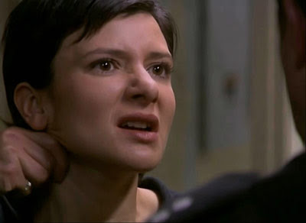

At first your father didn’t want to endanger his family. But sometimes life without freedom is no life at all.
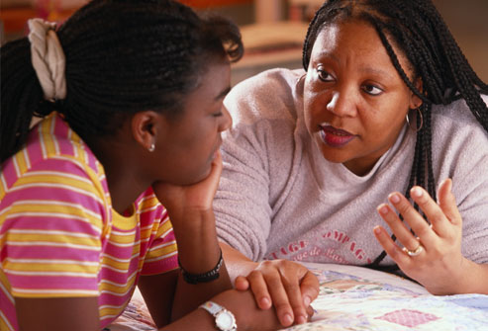

I go back to my room and erase every page of my diary.
